Event-Driven Telemetry Experiment

Infrastructure Design

Executive Summary
This document outlines the technical design for implementing an event-driven telemetry infrastructure to capture user interaction events for time-on-task analytics. The solution leverages existing Azure Service Bus infrastructure and establishes a scalable foundation for future analytics initiatives.
Key Metrics:
- Timeline: 7-9 weeks (45-59 developer days)
- Scope: 2 pilot workflows + foundational infrastructure
- Target SLA: < 5 minutes ingestion latency, ≥ 95% event accuracy, ≥ 90% workflow coverage

Glossary
BI - Business Intelligence
E2E - End-to-End
JWT - JSON Web Token
NTP - Network Time Protocol
PII - Personally Identifiable Information
SLA - Service Level Agreement
UAT - User Acceptance Testing
UUID - Universally Unique Identifier
Analytics Warehouse - Data storage system optimized for analytics queries (Azure Synapse or AWS Redshift)
Azure Service Bus - Message queue/streaming platform for event transport
Consumer Service - Backend service that reads events from Azure Service Bus and loads them into the analytics warehouse
Dead-Letter Queue - Queue for events that failed processing after maximum retry attempts
Emission Point - Location in code where events are created and sent to Azure Service Bus
Event Schema - JSON structure defining the format of telemetry events
FastAPI - Python web framework for building APIs
Partition Key - Field used to route events to specific partitions in Azure Service Bus (ensures ordering within partition)
Session ID - Unique identifier for a user session, generated on frontend and consistent throughout the session
Time-on-Task - Metric measuring how long users spend completing specific workflows or actions
Workflow - A sequence of user actions to complete a business process (e.g., logging, fulfillment, attestation)

1. Context & Requirements

1.1 Problem Statement
We lack a consistent, event-based framework for measuring user time-on-task across workflows. Without reliable telemetry, we cannot quantify workflow efficiency, identify friction points, or measure the impact of design changes.

1.2 Goals
- Create scalable, event-driven logging infrastructure
- Capture discrete user interactions with accuracy required for time-on-task calculation
- Establish standardized telemetry model for future analytics
- Enable BI/analytics teams to build dashboards and benchmarks

1.3 Out of Scope
- Downstream BI dashboards or time-on-task calculations (Phase 2)
- UX or interface changes
- Historical backfill or data migration
- Full workflow instrumentation (limited to 2 pilot workflows)

1.4 Acceptance Criteria
- Events for at least 2 workflows are emitted, transmitted, and stored successfully
- All events include timestamp, user/session identifier, and standardized event type
- Events appear in analytics data store within 5 minutes of emission
- Schema documentation and validation tests are complete
- 100% compliance with data privacy and security standards

2. Architecture Overview

2.1 High-Level Flow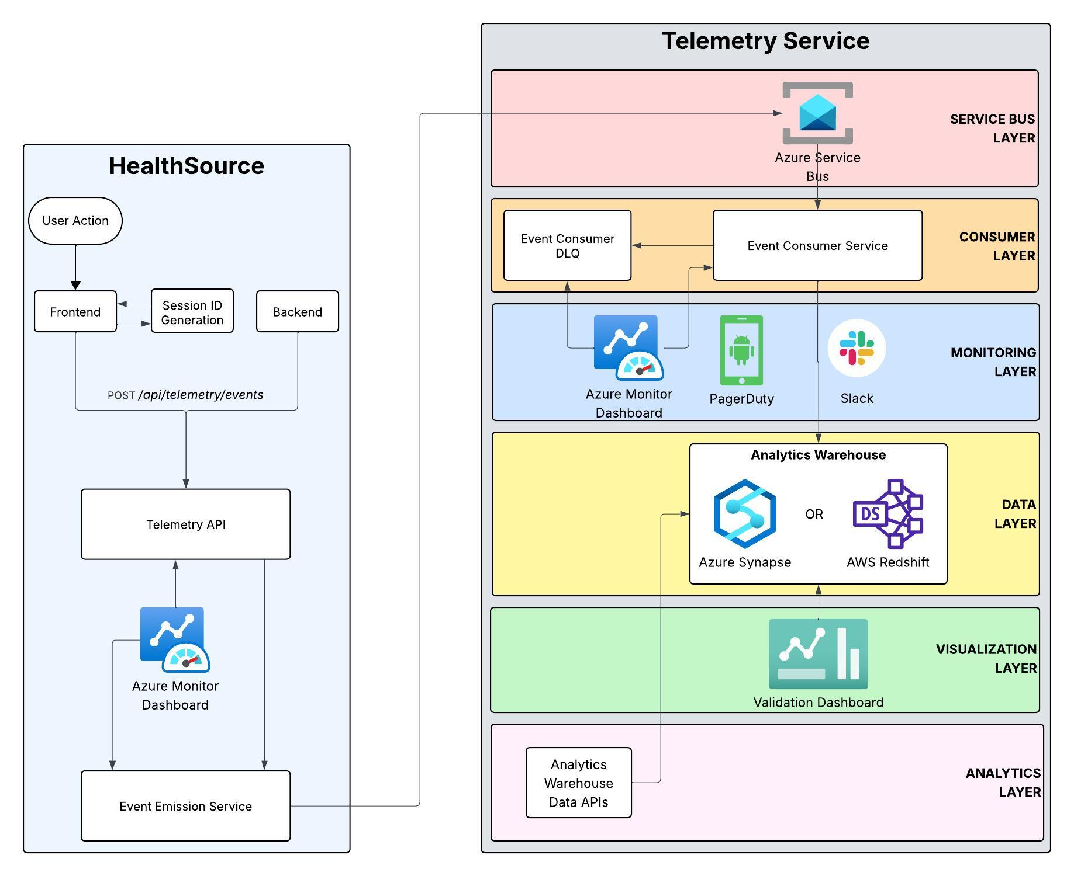
Note: Frontend events route through backend API endpoint to ensure server-side timestamp generation and eliminate time drift issues.

2.2 Key Components
- Event Schema Library - Shared Python library defining event structure
- Event Emission Service - Client library for emitting events
- Azure Service Bus Queue - Message broker for event transport
- Event Consumer Service - New FastAPI service consuming and loading events
- Analytics Warehouse - Data storage (Azure Synapse/AWS Redshift)
- Validation Dashboard - Simple UI for monitoring event health

2.3 Technology Stack
- Backend: Python/FastAPI (existing stack)
- Frontend: Angular/React (existing stack)
- Message Queue: Azure Service Bus (existing infrastructure)
- Analytics: Azure Synapse/AWS Redshift (TBD by Analytics Engineering)
- Monitoring: Datadog (existing)
- Database: PostgreSQL (for consumer service state, if needed)

3. Technical Design

3.1 Event Schema
Note: This is the schema of the event sent to the Azure Service Bus by the backend API.

{
"event_id": "evt_<uuid>",
“application_name”: "healthsource”,
"timestamp": "2024-01-15T10:00:00.000Z",
"user_id": "user_<id>",
"session_id": "sess_<uuid>",
"event_type": "workflow.start | workflow.active | workflow.complete | workflow.abandoned",
"workflow_name": "logging | fulfillment | attestation",
"metadata": {
"request_id": "<optional>",
"task_id": "<optional>",
"workflow_instance_id": "<optional>",
"additional_context": {}
}
}

Schema Constraints:
- event_id: UUID, globally unique
- application_name: MUST be a valid application name from the datavant_applications table
- timestamp: ISO 8601 format, UTC, server-generated (see Timestamp Strategy below)
- user_id: Extracted from JWT token
- session_id: Generated on frontend, consistent across session
- event_type: Enum (start, active, complete, abandoned)
- metadata: JSON object, no PII allowed

3.2 Timestamp Strategy
Problem: Client-side timestamps suffer from time drift due to incorrect system clocks, timezone misconfigurations, or clock skew across devices.

Solution: Server-Side Timestamp Generation
All event timestamps must be generated server-side to ensure accuracy and consistency:

Backend Events:
- Timestamp generated at emission point using server system time
- Server clocks synchronized via NTP (standard infrastructure practice)
- Format: ISO 8601 UTC (datetime.utcnow() in Python)

Frontend Events:
- Frontend sends events to backend API endpoint (not directly to queue)
- Backend API generates timestamp upon receipt
- Alternative: Frontend includes client_timestamp in metadata for reference, but timestamp field is overwritten by backend

Implementation:
# Backend emission (Python)
from datetime import datetime
from uuid import uuid4

event_id = uuid4()
event = TelemetryEvent(
event_id=f"evt_{event_id}",
application_name=”healthsource”,
timestamp=datetime.utcnow(), # Server time, UTC
user_id=user_id,
session_id=session_id,
event_type=event_type
)

Benefits:
- Eliminates time drift issues
- Consistent time source across all events
- Enables accurate time-on-task calculations
- Simplifies debugging and correlation
- Allows for usage by systems other than HealthSource

Note: If client-side timestamp is needed for debugging (e.g., to detect network latency), it can be included in metadata.client_timestamp but should not be used for calculations.

3.3 Session Management Strategy
Session ID Generation:
- Frontend generates UUID on application start/login
- Stored in localStorage with expiration (24 hours)
- Sent in custom HTTP header: X-Session-Id
- Backend extracts from request context

Session Lifecycle:
- Created: On login or application start
- Multiple Sessions: Users can have multiple concurrent sessions (different tabs, devices, or browser instances)
- Each session maintains its own session_id for the duration of that session
- Expired: After 24 hours of inactivity or explicit logout
- New Login: Creates a new session_id without invalidating existing sessions (allows concurrent sessions despite current HealthSource limitations)

Session Timeout Handling:
- Heartbeat events every 2-5 minutes for active workflows
- If no events received for 15 minutes → mark session as "abandoned"
- Consumer service handles timeout logic server-side

3.4 Event Partitioning & Ordering
Azure Service Bus Partitioning:
- Use session_id as partition key
- Ensures all events for same session go to same partition
- Maintains ordering within session as we don’t want to receive logs out of order
- Enables parallel processing across sessions

Ordering Guarantees:
- Events within same session: Ordered
- Events across sessions: May be out of order (acceptable)
- Consumer processes events sequentially per partition

3.5 Event Types & Lifecycle

Workflow Events:
- workflow.start - User initiates workflow
- workflow.active - Heartbeat (every 2-5 min during active use)
- workflow.complete - User completes workflow successfully
- workflow.abandoned - Session timeout or browser close detected

Event Emission Points:
Backend:
- Workflow state transitions (workflow_service.complete_workflow())
- Task events (workflow_router.task_event())
- Request status changes

Frontend:
- Workflow initiation (user clicks "Start")
- Form submissions
- Page navigation within workflow
- Browser visibility changes (pause/resume)

3.6 Data Flow

Emission Path:
Frontend Events:
- Frontend calls backend API endpoint: POST /api/telemetry/events
- Backend API generates server-side timestamp, validates schema
- Backend emits event to Azure Service Bus queue asynchronously
- Returns success response to frontend (non-blocking)

Backend Events:
- Application code calls TelemetryEventService.emit(event)
- Service generates server-side timestamp, validates schema, adds metadata
- Event sent to Azure Service Bus queue asynchronously (non-blocking)
- Returns immediately (fire-and-forget pattern)

Consumption Path:
- Consumer service polls Azure Service Bus
- Validates event schema
- Transforms to warehouse format
- Batch loads to analytics warehouse
- Handles failures with retry and a dead-letter queue

Error Handling:
- Invalid events → Dead-letter queue + alert
- Consumer failures → Retry with exponential backoff
- Warehouse load failures → Retry + alert
- Network failures → Queue persistence (events retained)

4. Infrastructure Design

4.1 Azure Service Bus Configuration

Queue/Topic:
- Name: hs-telemetry-events
- Type: Topic with subscriptions (enables multiple consumers if needed)
- Partitioning: Enabled, keyed by session_id
- Retention: 7 days (configurable)
- Max delivery count: 10 (then dead-letter)

Access Policies:
- Producer: Shared access key for emitting services
- Consumer: Shared access key for consumer service
- Environmental Keys: Separate keys per environment (qa01, try, prod)

4.2 Analytics Warehouse Schema
CREATE TABLE datavant_applications (
application_id SERIAL PRIMARY KEY,
application_name VARCHAR(100) UNIQUE NOT NULL,
description TEXT,
owning_team VARCHAR(100),
created_at TIMESTAMP DEFAULT CURRENT_TIMESTAMP,
created_by VARCHAR(255) NOT NULL,
is_active BOOLEAN DEFAULT TRUE
);

CREATE TABLE user_interaction_events (
event_id VARCHAR(36) PRIMARY KEY,
application_id INTEGER NOT NULL REFERENCES datavant_applications(application_id) ON DELETE RESTRICT,
timestamp TIMESTAMP NOT NULL,
user_id VARCHAR(255) NOT NULL,
session_id VARCHAR(36) NOT NULL,
event_type VARCHAR(50) NOT NULL,
workflow_name VARCHAR(100),
metadata JSONB,
ingested_at TIMESTAMP DEFAULT CURRENT_TIMESTAMP,
partition_date DATE GENERATED ALWAYS AS (DATE(timestamp)) STORED
) PARTITION BY RANGE (partition_date);

CREATE INDEX idx_application_id ON user_interaction_events(application_id, timestamp);
CREATE INDEX idx_session_id ON user_interaction_events(session_id, timestamp);
CREATE INDEX idx_user_id ON user_interaction_events(user_id, timestamp);
CREATE INDEX idx_workflow ON user_interaction_events(workflow_name, timestamp);
CREATE INDEX idx_application_workflow ON user_interaction_events(application_id, workflow_name, timestamp);
CREATE INDEX idx_created_by ON datavant_applications(created_by, is_active);

4.3 Event Consumer Service

Architecture:
- FastAPI application
- Azure Service Bus consumer (batch processing)
- Schema validation layer
- Warehouse loader (batch inserts)
- Health check endpoints
- Metrics emission to Datadog

Configuration:
- Batch size: 100 events
- Polling interval: 5 seconds
- Max batch processing time: 30 seconds
- Retry policy: Exponential backoff (max 3 retries)

Monitoring:
- Event processing rate
- Latency (emission → warehouse)
- Error rates
- Consumer lag
- Dead-letter queue depth

4.4 Validation Dashboard

Purpose:
- Operational monitoring and acceptance criteria validation

Features:
- Event volume metrics (last 24h, 7d, 30d)
- Ingestion latency indicator (<5 min SLA)
- Error rates by type
- Event completeness by workflow
- Recent events table (last 100, filterable)
- Data quality indicators

Technology:
- Angular/React (reuse existing frontend stack)

5. Implementation Plan

5.1 Phase 1: Foundation (Weeks 1-2)

Deliverables:
- Event schema library (modules/python/libs/telemetry/)
- Event emission service
- Azure Service Bus configuration
- Basic unit tests

Files:
- modules/python/libs/telemetry/telemetry/event.py
- modules/python/libs/telemetry/telemetry/service.py
- modules/python/libs/telemetry/telemetry/config.py

5.2 Phase 2: Backend Instrumentation (Weeks 3-4)

Deliverables:
- Instrument 2 pilot workflows (logging, fulfillment)
- Session ID extraction from request context
- Integration tests

Files:
- services/eipservices/.../workflow_service.py (add event emission)
- services/eipservices/.../workflow_router.py (add event emission)
- services/requestworker/.../workflow_router.py (add event emission)

5.3 Phase 3: Frontend Instrumentation (Weeks 4-5)

Deliverables:
- Session ID generation and management
- Event emission service
- Instrument workflow components
- Integration tests

Files:
- frontends/cipui/cipui/app/common/services/telemetryEventService.js (new - calls backend API)
- frontends/cipui/cipui/app/request/services/requestHelperSvc.js (modify)
- frontends/cipui/cipui/app/logging/controllers/requestDetailsEditCtrl.js (modify)
- frontends/platformui/src/app/services/authentication/user-authentication.service.ts (add session tracking)

Backend API endpoint:
- services/platformservices/.../telemetry_controller.py (new - receives frontend events, generates timestamp)

5.4 Phase 4: Consumer Service (Weeks 5-6)

Deliverables:
- New FastAPI consumer service
- Schema validation
- Warehouse loader
- Error handling and retries
- Health checks

Files:
- services/telemetryconsumer/ (new service)
- services/telemetryconsumer/telemetryconsumer/consumer_service.py
- services/telemetryconsumer/telemetryconsumer/warehouse_loader.py

5.5 Phase 5: Analytics Warehouse Setup (Week 6)

Deliverables:
- Schema creation
- Partitioning configuration
- Retention policies
- Data pipeline setup

Owner:
- Analytics Engineering (parallel work)

5.6 Phase 6: Validation Dashboard (Week 7)

Deliverables:
- Simple Angular/React dashboard
- Event metrics display
- Data quality indicators
- Recent events viewer

Files:
- frontends/platformui/src/app/telemetry-dashboard/ (new)

5.7 Phase 7: Testing & Validation (Weeks 7-8)

Deliverables:
- End-to-end testing
- Manual test execution
- Data validation (accuracy, completeness, latency)
- Performance testing
- UAT

5.8 Phase 8: Documentation & Deployment (Week 9)

Deliverables:
- Schema documentation
- Instrumentation guide
- Runbooks
- Production deployment
- Monitoring setup

6. Risk Assessment & Mitigation

6.1 Technical Risks

Risk | Impact | Probability | Mitigation
Data privacy violations (PII) | Critical | Low | Schema validation, PII redaction layer, privacy review
Event overload / excessive volume | High | Medium | Heartbeat sampling (2-5 min), only active workflows
Client-side timestamp drift | High | Medium | Server-side timestamp generation, NTP synchronization
Event schema drift across teams | High | Medium | Shared schema library, validation at ingestion
Consumer lag / latency >5 min | High | Low | Monitoring alerts, auto-scaling consumer
Session ID inconsistency | Medium | Low | Standardized generation in shared service

6.2 Operational Risks
Risk | Impact | Probability | Mitigation
Azure Service Bus failures | High | Low | Queue persistence, retry logic, monitoring
Low adoption / inconsistent instrumentation | Medium | Medium | Clear documentation, SDK examples, code review
Warehouse performance degradation | Medium | Low | Partitioning, indexing, retention policies

6.3 Timeline Risks
Risk | Impact | Mitigation
Session ID strategy unclear | +2-3 days | Define early, document decision
Complex workflow state tracking | +3-5 days | Start with simple workflows, iterate
Analytics warehouse integration delays | +2-4 days | Early engagement with Analytics Engineering
Security Issue(s) Found | +3-5 days? | Early engagement with Security Engineering

7. Success Metrics

7.1 Technical Metrics
- Event Accuracy: ≥95% timestamp accuracy (validated against manual logs)
- Coverage: ≥90% of target workflows instrumented
- Latency: <5 minutes from emission to query readiness
- Reliability: <0.1% event loss rate
- Schema Compliance: 100% of events pass validation

7.2 Operational Metrics
- Consumer Lag: <1 minute average
- Error Rate: <0.5% of events in dead-letter queue
- Dashboard Uptime: >99.9%
- Data Freshness: Events queryable within 5 minutes

7.3 Business Metrics (Phase 2)
- Time-on-task measurement accuracy
- Workflow friction point identification
- Analytics team productivity improvement

8. Dependencies

8.1 Internal Dependencies
- Platform Engineering: Azure Service Bus queue creation and configuration
- Analytics Engineering: Warehouse schema design, data pipeline setup
- Security/Privacy: Compliance review, PII validation
- DevOps: Deployment pipeline, monitoring setup

8.2 External Dependencies
- Azure Service Bus availability
- Analytics warehouse (Azure Synapse/AWS Redshift) access and capacity

9. Open Questions
- Analytics Warehouse Selection: Azure Synapse or AWS Redshift? (Decision needed from Analytics Engineering)

- Heartbeat Frequency: Optimal interval for workflow.active events? (Recommendation: 2-5 minutes)

- Event Retention: Exact retention period for raw events? (Recommendation: 90 days)

- Workflow Selection: Which 2 workflows for pilot? (Recommendation: logging and fulfillment)

- Validation Dashboard Access: Who should have access? (Recommendation: Engineering and Analytics teams)

- Frontend Event API Endpoint: Should frontend events go through existing API gateway or dedicated telemetry endpoint? (Recommendation: Dedicated endpoint for separation of concerns)

10. Future Considerations

10.1 Phase 2 Enhancements
- Expand instrumentation to all workflows
- Time-on-task calculation service
- Advanced analytics dashboards
- ML-based productivity insights
- Heartbeat configuration per-service
  - Enabled/Disabled
  - Heartbeat frequency

10.2 Scalability Considerations
- Event sampling strategies for high-volume workflows
- Consumer service horizontal scaling
- Warehouse query optimization
- Cost optimization (storage, compute)

10.3 Integration Opportunities
- Integration with existing Datadog metrics
- Correlation with application performance metrics
- Real-time alerting for workflow anomalies

Appendices

Appendix A: Event Schema JSON Schema
{
"$schema": "http://json-schema.org/draft-07/schema#",
"type": "object",
"title": "Telemetry Event Schema",
"description": "Schema for user interaction telemetry events",
"required": [
"event_id",
"application_name",
"timestamp",
"user_id",
"session_id",
"event_type"
],
"properties": {
"event_id": {
"type": "string",
"pattern": "^evt_[0-9a-f]{8}-[0-9a-f]{4}-[0-9a-f]{4}-[0-9a-f]{4}-[0-9a-f]{12}$",
"description": "Unique event identifier with 'evt_' prefix followed by UUID"
},
"application_name": {
"type": "string",
"pattern": "^[a-z0-9_]+$",
"minLength": 1,
"maxLength": 100,
"description": "Application name in lowercase (e.g., 'healthsource')"
},
"timestamp": {
"type": "string",
"format": "date-time",
"description": "ISO 8601 UTC timestamp when event was generated (server-side)"
},
"user_id": {
"type": "string",
"minLength": 1,
"maxLength": 255,
"description": "Unique identifier for the user"
},
"session_id": {
"type": "string",
"pattern": "^sess_[0-9a-f]{8}-[0-9a-f]{4}-[0-9a-f]{4}-[0-9a-f]{4}-[0-9a-f]{12}$",
"description": "Session identifier with 'sess_' prefix followed by UUID"
},
"event_type": {
"type": "string",
"enum": [
"workflow.start",
"workflow.active",
"workflow.complete",
"workflow.abandoned"
],
"description": "Type of workflow event"
},
"workflow_name": {
"type": "string",
"maxLength": 100,
"description": "Name of the workflow (e.g., 'logging', 'fulfillment', 'attestation')"
},
"metadata": {
"type": "object",
"description": "Additional context-specific metadata",
"properties": {
"request_id": {
"type": "string",
"description": "Optional request identifier"
},
"task_id": {
"type": "string",
"description": "Optional task identifier"
},
"workflow_instance_id": {
"type": "string",
"description": "Optional workflow instance identifier"
},
"additional_context": {
"type": "object",
"description": "Additional context as key-value pairs",
"additionalProperties": true
}
},
"additionalProperties": false
}
},
"additionalProperties": false
}

Appendix B: Estimated Effort Breakdown
Component | Developer Days | Notes
Event Schema Library | 3-5 | Includes unit tests
Backend Instrumentation (2 workflows) | 6-8 | Includes integration tests
Frontend Instrumentation | 4-6 | Includes integration tests
Consumer Service | 5-7 | Includes error handling
Analytics Warehouse Setup | 2-3 | Analytics Engineering
Validation Dashboard | 4-6 | Simple Angular/React UI
Manual Testing | 4-6 | Test execution, UAT
Security Review | 3-4 | Work with Security Team
Documentation | 2-3 | Schema, guides, runbooks
Code Review & Iteration | 2-4 | Reviews, bug fixes
Total | 45-59 | 7-9 weeks calendar

Appendix C: Document History
Author | Joseph Montero | V 1.0 | 2026-01-13
First Reviewer
Second Reviewer

